School Voting System (voting-app3)

System Design Specification

Version 1.0 — November 3, 2026
Prepared from the codebase and the interactive guide (guide/)

Table of Contents
Right-click here and choose “Update Field” to build the table of contents.

1. Introduction
This document describes how the School Voting System (voting-app3) is designed: its architecture, data flows, use-case realization, dynamic behavior, database structure, interface organization, and deployment topology. It translates the requirements in the SRS into a technical blueprint that matches the implemented code.

2. System architecture

2.1 Architectural style
A three-tier, server-rendered PHP application with selective single-page (SPA) behavior:
- Client tier — HTML rendered by PHP, plus hand-rolled vanilla JavaScript. The student dashboard and admin dashboard are SPA-style shells: one HTML page, seven (admin) or four (student) panels switched client-side, fed by JSON endpoints.
- Application tier — stateless PHP page controllers and JSON endpoints; a shared helper module implements cross-cutting concerns (sessions, CSRF, rate limiting, validation, year-level engine, image validation, election-status synchronization).
- Data tier — a relational database accessed exclusively through PDO prepared statements; dual driver (MariaDB locally, PostgreSQL/Neon in production) selected at runtime.
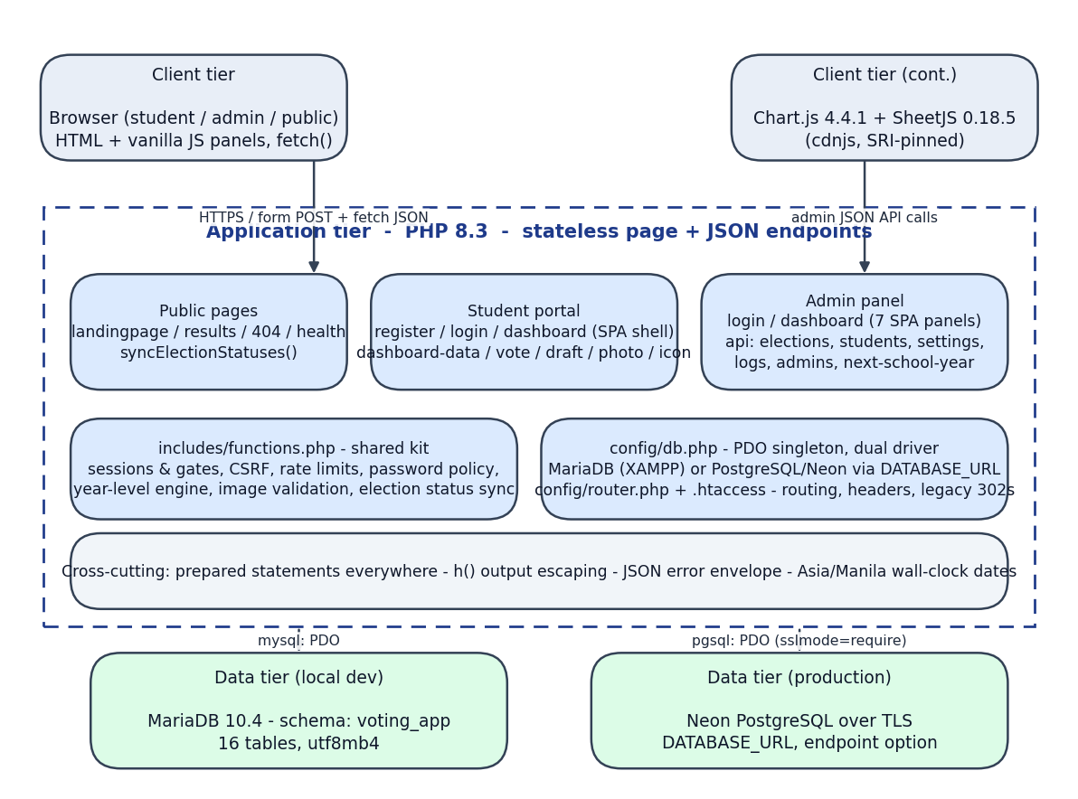
System architecture
Figure 2-1. Architecture overview: client, application, and data tiers with the shared helper kit and dual-database driver.

2.2 Module map
Module | Responsibility
--- | ---
public/index.php | Session-aware entry redirector (dashboard if logged in, else landing page)
public/landingpage.php | Public landing page: hero, live banner, election cards, candidate marquee, stats ticker
public/results.php | Public results (server-side visibility enforcement; ?partial=1 fragment for 15-second refresh)
public/404.php, public/health.php | Branded 404; JSON health probe used by the uptime monitor
student/register.php | Self-registration / activation of admin-created accounts
student/login.php, student/logout.php | Student authentication with lifecycle gates; logout
student/dashboard.php | Dashboard shell + ballot page (single or combined; admin preview=1 mode)
student/dashboard-data.php | One batched JSON payload powering all student panels
student/vote.php | Transactional ballot submission (POST JSON)
student/draft.php | Ballot draft save/load (JSON upsert)
student/update-account.php | Year-level / lifecycle declaration (forced or voluntary)
student/change-password.php | Forced password change after admin reset
student/photo.php, student/icon.php | Read-only image streaming from DB (candidates; SSG/faculty logos)
admin/login.php, admin/logout.php, admin/index.php | Admin authentication and routing
admin/dashboard.php | Admin SPA shell with seven panels and all panel logic
admin/api/elections.php | Election CRUD, lifecycle, positions/candidates, photos, duplicate guard
admin/api/students.php | Student CRUD (no delete), temp-password reset, voted-status evidence
admin/api/settings.php | Faculties, year levels, school years, logos, maintenance prunes
admin/api/logs.php | Audit trail read, throttle bucket view + unblock
admin/api/admins.php | Admin account management
admin/api/next-school-year.php | "Archive All & Start New Cycle" transaction
includes/functions.php | Shared kit: 28 helpers (sessions, CSRF, rate limits, JSON envelope, year engine, images, settings, banners)
config/db.php | PDO singleton; driver resolution; dialect helpers
config/router.php, .htaccess | Routing (legacy 302 map), security headers, traversal guard
guide/ | Local-only guided-tour companion (reads source; writes nothing)

3. Context diagram
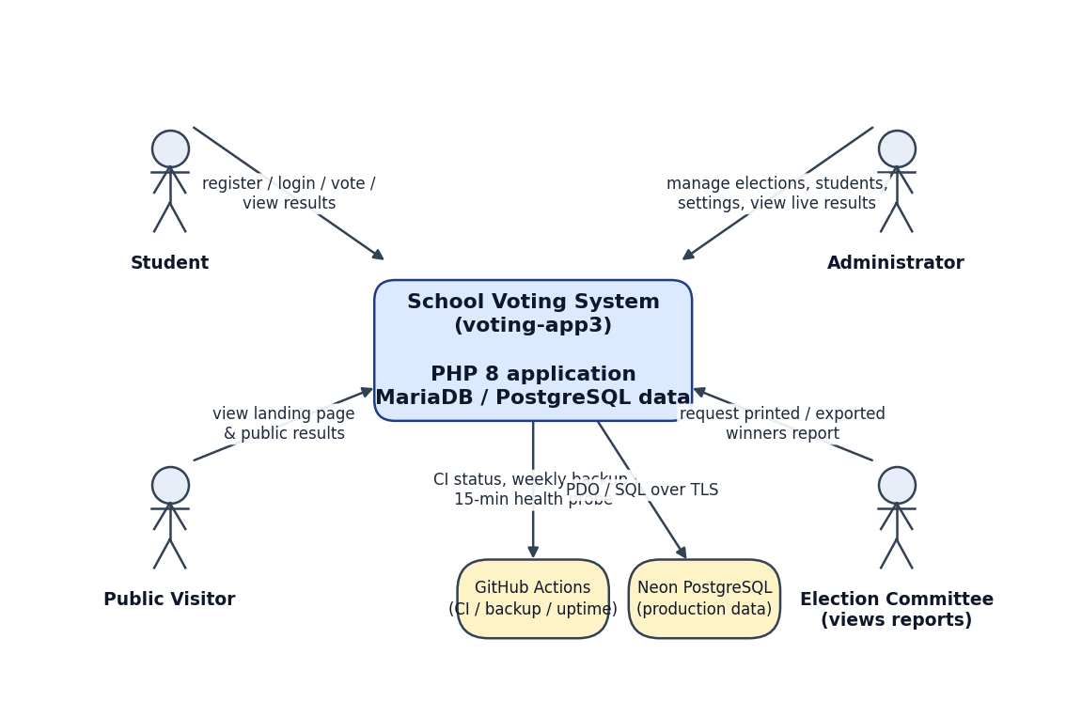
Context diagram
Figure 3-1. System context. Four actor roles interact with the system; GitHub Actions provides CI/backup/uptime automation; Neon PostgreSQL is the production data store.

4. Data-flow diagrams

4.1 Level 0
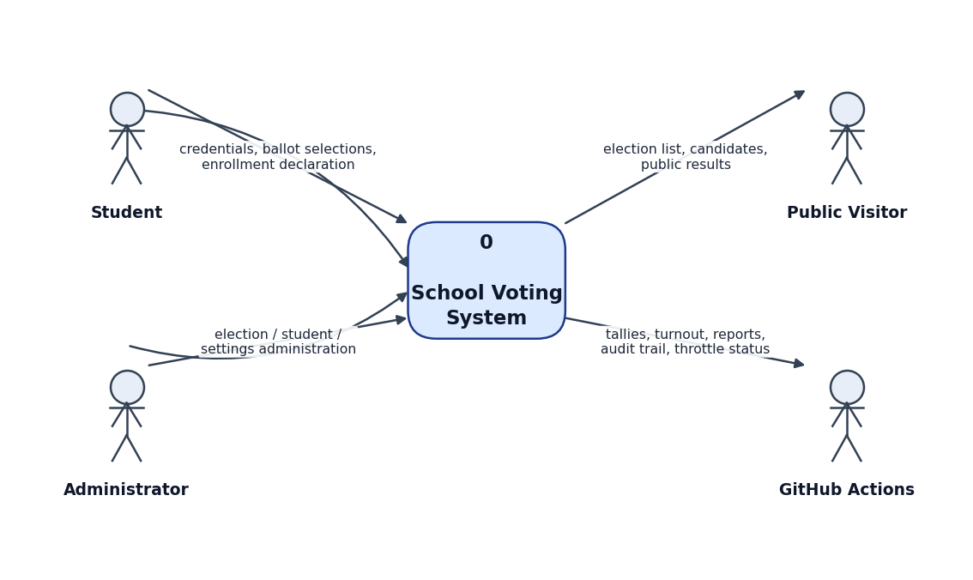
DFD Level 0
Figure 4-1. Level-0 DFD. Students supply credentials, ballot selections, and enrollment declarations; administrators manage elections, students, and settings; visitors read public data; GitHub Actions consumes health/backup interfaces.

4.2 Level 1
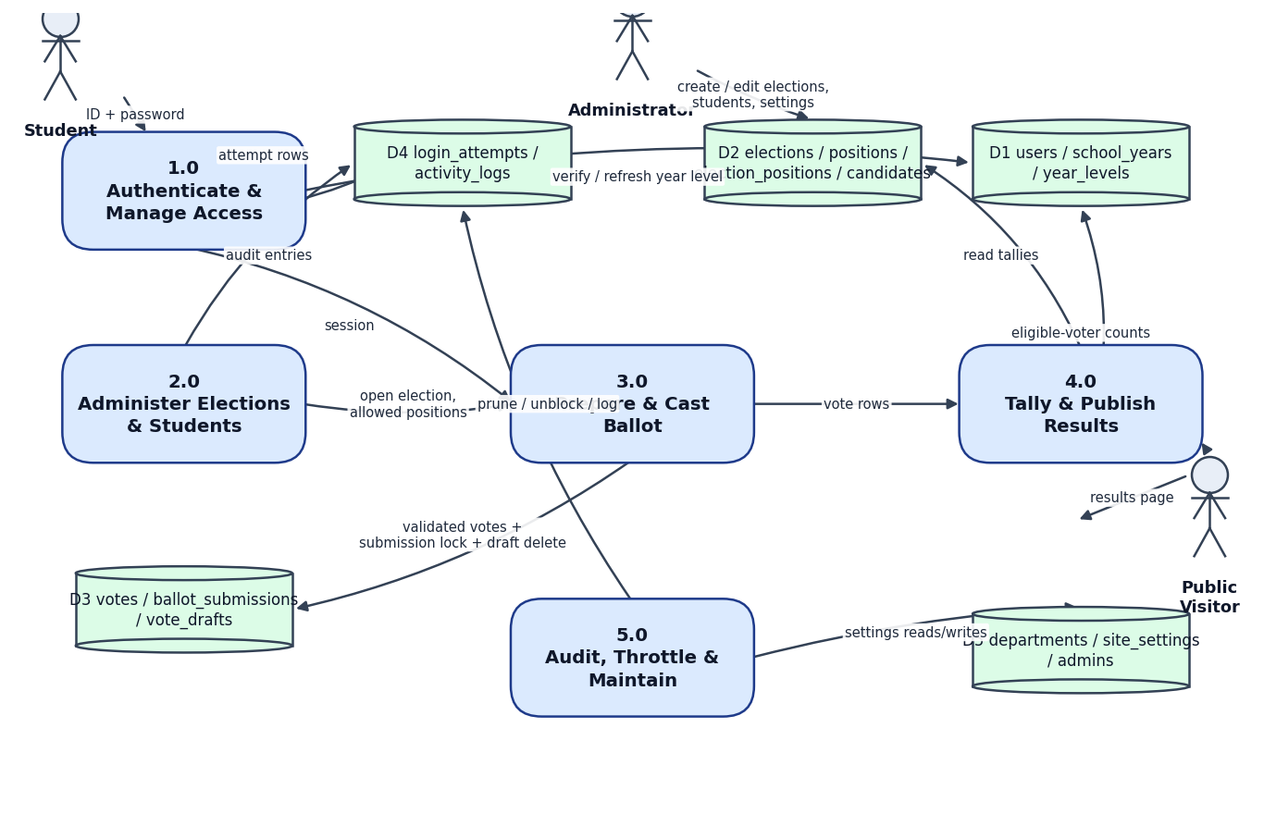
DFD Level 1
Figure 4-2. Level-1 DFD. Processes: 1.0 Authenticate & Manage Access; 2.0 Administer Elections & Students; 3.0 Prepare & Cast Ballot; 4.0 Tally & Publish Results; 5.0 Audit, Throttle & Maintain. Stores: D1 identity/school-year data; D2 election definitions; D3 voting evidence; D4 attempt/audit logs; D5 reference data & admin accounts.

5. Use-case realization
The full use-case diagram and descriptions are in the SRS (Section 7). Realization summary:
Use case | Realizing components
--- | ---
Register account | student/register.php (+ resolveYearDeclaration, getOrCreateSchoolYear)
Log in | student/login.php / admin/login.php (+ computeYearLevel, isRateLimited)
Cast ballot | student/dashboard.php (ballot branch) + student/vote.php (transaction)
Save/load draft | student/draft.php (JSON upsert with unique key per user+election)
Manage elections | admin/dashboard.php election panel + admin/api/elections.php
Manage student records | admin/dashboard.php students panel + admin/api/students.php
Publish results/reports | public/results.php, admin Results panel (client-side exports)
Year-end rollover | admin/api/next-school-year.php (single transaction)

6. Dynamic design

6.1 Activity diagram — casting a ballot
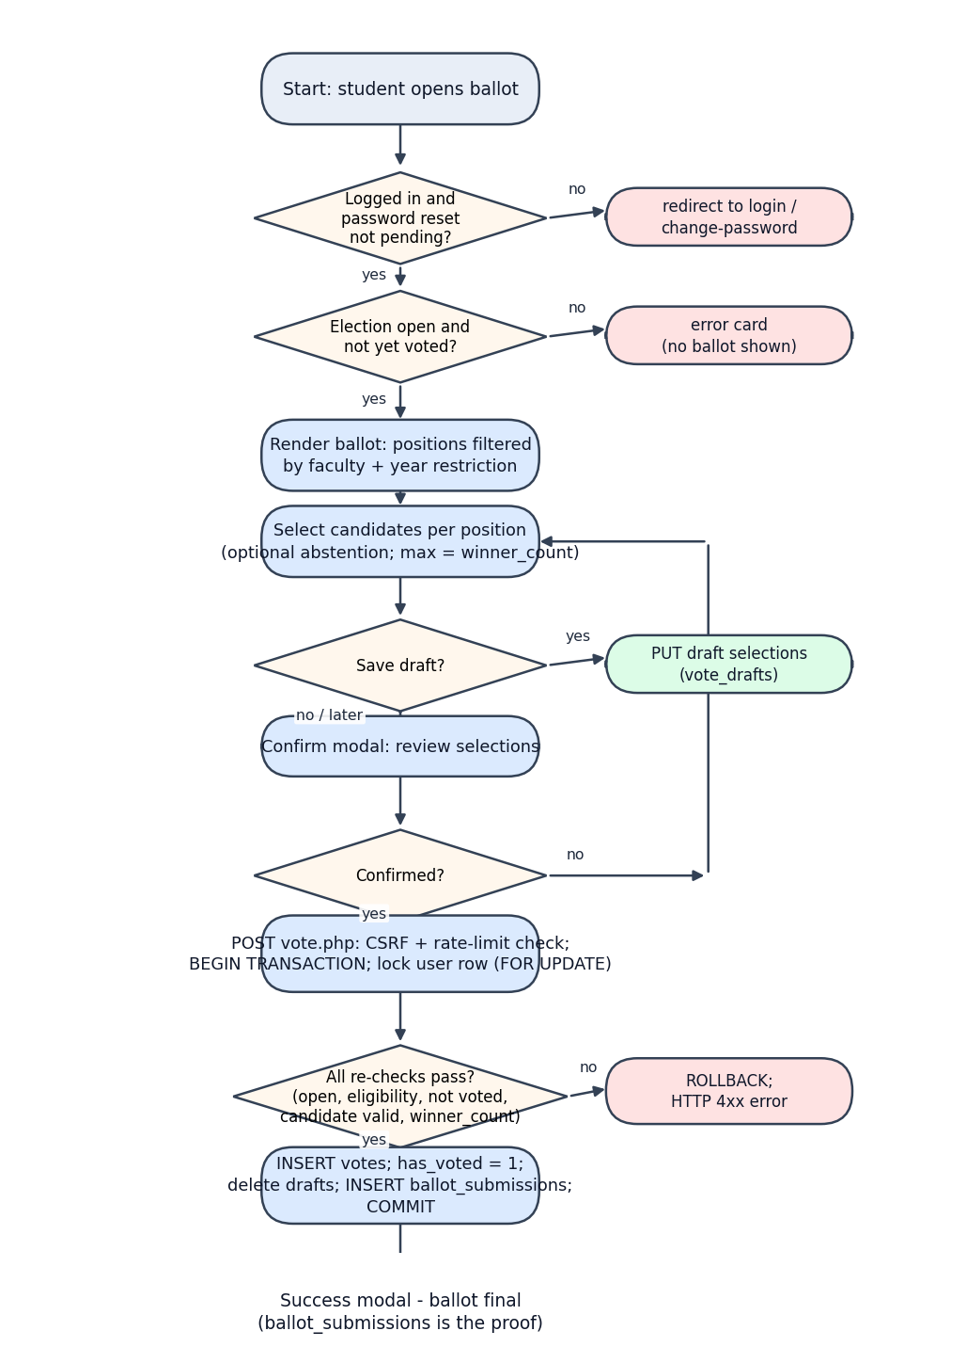
Activity diagram: voting
Figure 6-1. Voting activity flow, from ballot render through transactional submission. Every "no" branch is handled without writing data; only the final commit creates evidence.

6.2 Sequence diagram — ballot submission
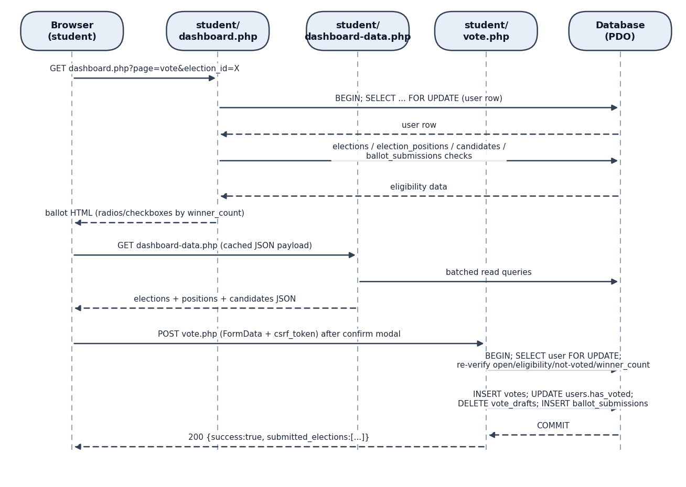
Sequence diagram: ballot submission
Figure 6-2. Submission sequence. The ballot page acquires a row lock and reads eligibility inside the render; the submission endpoint re-verifies everything inside one transaction before writing votes, deleting drafts, and inserting the submission lock.

6.3 Election lifecycle state machine
save schedule start window opens draft ─────────────────▶ scheduled ─────────────────────▶ ongoing
(syncElectionStatuses) │ ▲
manual pause │ │ resume
▼ │
paused
ongoing ──── end window reached (syncElectionStatuses) ──▶ closed
closed ──── archive (manual or Archive-All) ─────────────▶ archived
archived ── restore ─────────────────────────────────────▶ closed (voting stays closed)
any non-archived ── "Next School Year Election" ─────────▶ archived (bulk)
closed/archived with confirm_delete ─────────────────────▶ deleted (votes destroyed)
- scheduled→ongoing and ongoing/scheduled→closed happen lazily via syncElectionStatuses() on every election-reading request (Manila wall-clock).
- draft, paused, archived are never auto-transitioned.
- Activation/scheduling re-runs the duplicate guard (one SSG per target year; one DSG per faculty per target year, archived included).

6.4 School-year clock and year-level engine
currentSchoolYearStartYear(): June 1 cutover, Asia/Manila Jan–May → previous calendar year Jun–Dec → current calendar year
computeYearLevel(studentStartYear, activeStartYear):
index = activeStartYear − studentStartYear + 1 (clamped ≥ 1)
label = index-th year_levels row by sort_order (index 1–4)
blocked = index ≥ 5
login (normal students): refresh users.year_level when index ≤ 4;
index ≥ 5 without a declaration → force update-account.php
dropped/graduated → login refused

7. Database design
The complete data dictionary is in the Database Design and Data Dictionary document. Design summary:
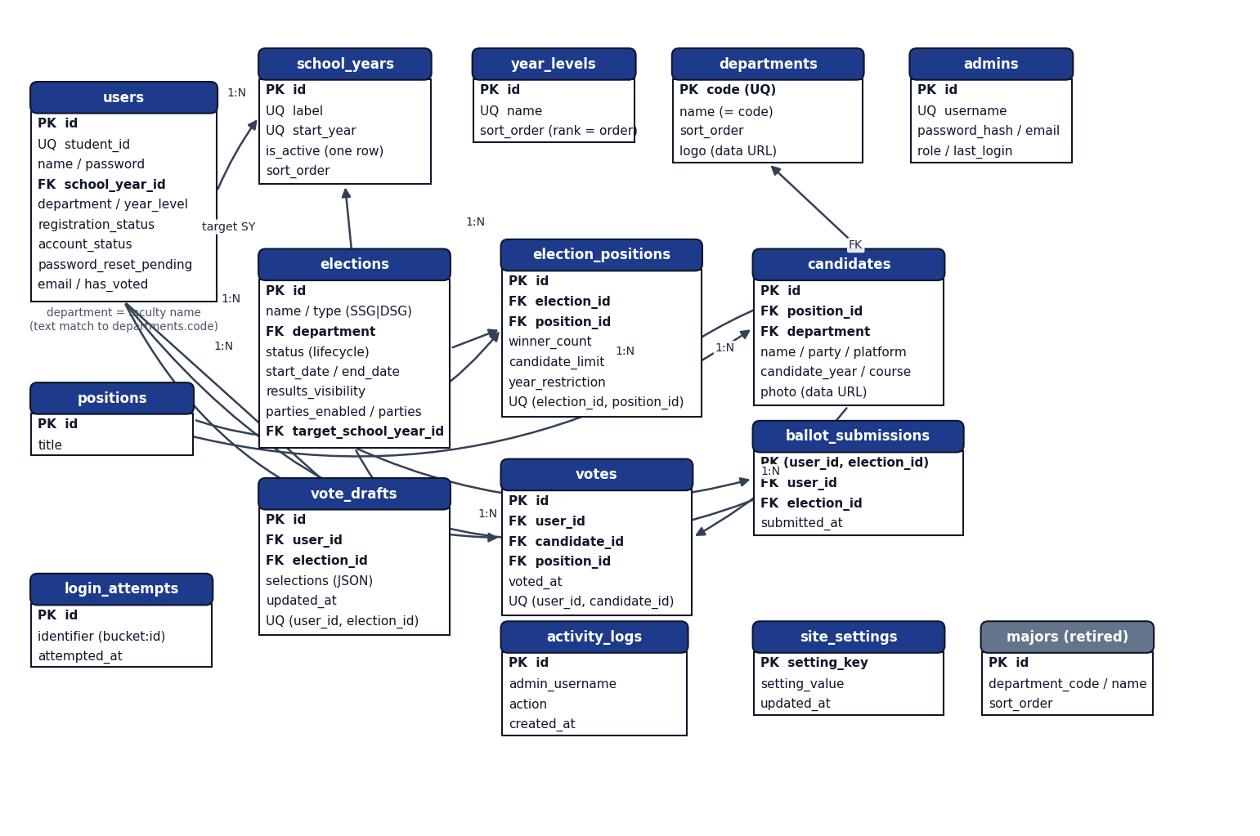
Entity-relationship diagram
Figure 7-1. ERD of the 16-table schema. Voting evidence (`votes`, `ballot_submissions`) is the heart of the design; `election_positions` is the association entity that scopes positions and candidates per election; the `school_years`/`year_levels`/`departments` reference tables drive computed eligibility.
Key design decisions:
- One ballot = one `ballot_submissions` row (primary key user_id, election_id) — the authoritative participation lock; votes rows are the per-candidate evidence and carry a UNIQUE (user_id, candidate_id) constraint as belt-and-braces.
- Positions are global; placement is per election through election_positions (winner_count, candidate_limit, year_restriction) — so position titles stay consistent while elections reference them.
- Candidates scope through `position_id` only (no election_id column) — an election's candidates are reachable only via its positions, enforced by integrity checks in the test suite.
- Images in the database as validated base64 data URLs (candidates.photo, departments.logo, site_settings.setting_value) — no filesystem state.
- School-year integrity: exactly one active year (partial unique index on PostgreSQL; generated-column guard on MariaDB).
- `majors` is retired but retained (empty, unmanaged) so migrations stay non-destructive.

8. User-interface design

8.1 Design system
- Consistent card-based layouts, light/dark themes (student: studentTheme; admin: adminTheme in localStorage), inline SVG iconography, skeleton loaders, toast/confirm/modal components.
- Typography: Sora (display), Inter (body), IBM Plex Mono (code/labels) via Google Fonts.
- Color coding: SSG accent blue (#3b82f6), DSG accent orange (#f97316); status badges for Draft/Upcoming/Ongoing/Paused/Ended/Archived.

8.2 Wireframes and captured screens
Recorded captures live in docs/design/screens/ (landing, login, register, results, mobile variants, admin dashboard tabs, student panels) and guide/screens/*.webp (annotated tour frames). Key layouts:
- Landing: hero + live banner; election cards; candidate marquee; stats ticker; footer.
- Student shell: left sidebar (Home, Vote Now, Candidates, Results), header with server date, profile card with theme toggle; panels swap client-side.
- Ballot: per-election blocks, per-position fieldsets (radio/checkbox by winner_count), sticky progress, confirm modal, success modal.
- Admin shell: sidebar with seven panels; stat tiles; Chart.js turnout donut + faculty bars; wizard as a two-step form with drag-reorder positions; results with Overview/Detail/Reports segmented views; logs grouped by day with a throttle card; settings with inline logo uploads and maintenance cards.

8.3 Navigation / sitemap
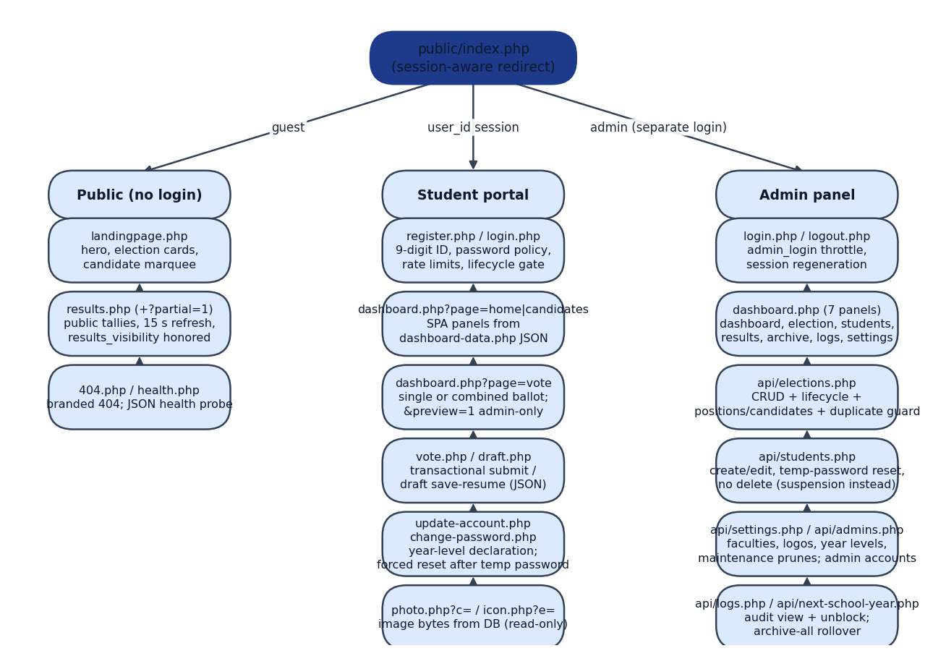
Sitemap
Figure 8-1. Navigation map. `public/index.php` is the single entry point: guests land on the public site, students on the dashboard; the admin panel is reached only through the separate admin login. Legacy root-level URLs 302-redirect to the restructured folders.

9. Deployment design
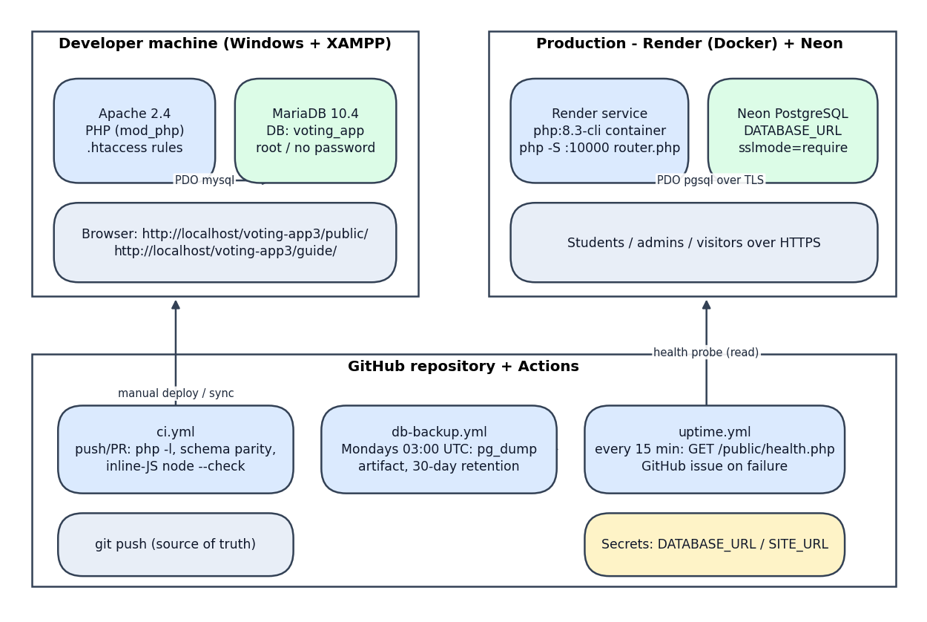
Deployment diagram
Figure 9-1. Deployment topology. Development runs on XAMPP; production runs the same code in a `php:8.3-cli` container on Render against Neon PostgreSQL; GitHub repository and Actions provide CI, weekly encrypted-at-rest backup artifacts, and 15-minute health monitoring.
Infrastructure notes:
- Stateless app container: no sessions persisted server-side beyond PHP's default file handler within a single instance; horizontal scaling would require shared session storage (not currently needed).
- Secrets: production credentials exist only as Render environment variables and GitHub secrets; .env files are gitignored, and .htaccess pins the local driver so local secrets never leak to production.
- Health contract: /public/health.php returns {"ok":true,"db":"up","time":...} (200) or {"ok":false,"db":"down",...} (503) — the exact interface uptime.yml monitors.

10. Key design decisions and rationale
Decision | Rationale
--- | ---
No framework, no build step | Deployment simplicity for a school project; everything reviewable in-file; CDN libs pinned by SRI
Dual-database driver | Free local development on XAMPP/MariaDB; production on managed Neon Postgres — one codebase, parity enforced by tests/schema_parity.php in CI
Lazy status synchronization instead of cron | Works on any host (no scheduler needed); cannot "forget" to run; drafts/paused/archived deliberately excluded from automation
SPA panels inside server-rendered shells | Fast panel switching without a client router; each panel fetches its own endpoint so one failure doesn't break the shell
Participation lock as a table (ballot_submissions) | "Already voted" is a primary-key insert away from being race-free; turnout counts distinct submissions, matching election terminology
Year level computed, not stored as truth | Promotion happens automatically on June 1 without admin action; stored label is a cache refreshed at login for normal students
Admins see participation, never ballots | Ballot secrecy is structural: no endpoint returns per-student selections; exports carry aggregates only
Photos as validated data URLs in DB | No filesystem permissions/uploads hardening; redeploy-safe; strict decoded-byte validation (JPEG/PNG/GIF/WebP, ≤2 MB, SVG rejected)
Guide reads source live via anchors | Documentation cannot silently drift from code: anchors are validated (guide/tools/test.sh), line numbers resolved at request time

Prepared November 2026 from the implemented system (source of truth: the code and test suite).

